FACULTY OF ENGINEERING AND TECHNOLOGY

**A REPORT ABOUTDATA VISUALISATION FROM DIFFERENT PARAMETERS, PATTERNS, TRAYS, RELATION SHEETS AND DESCRIBING STATISTICAL CHARACTERISTICS OF THE DATA**

COURSE UNIT: COMPUTER PROGRAMING

LECTURER: Mr. MASERUKA BENEDICTO

SUBMITTED BY: GROUP 16

E-MAIL: [matlabgroup16@gmail.com](mailto:matlabgroup16@gmail.com)

*Submitted in partial fulfillment of the requirements of* COMPUTER PROGRAMMING

*DATE OF SUBMISSION.............../............../..............*

*SUBMITTED TO: .****......................................................***

# DECLARATION

We, the group 16 members declare that this report is our original work carried out as part of Matlab course under the supervision of our lecturer Mr Maseruka Bendicto. All sources of information have been duly acknowledged and this work has not been submitted elsewhere for academic project

**NAME SIGNATURE**



KABWERU ANDREW .............................

CHEMONGES MIKIRAR .............................



NAGASHA RITTA ..............................



DIKITAL JOHN ..............................



SANYU JOY ...............................

OULE SADOCK ...............................



WANGUSI DAVID ................................



SEBATIKA COLLINE ................................

ATYANG MILDRED ................................



KITUTU LEONARD .................................

# APPROVAL

We present this report prepared entirely through our efforts and has been examine, comprehended as a partial requirement for our excellent for computer programming as well as award of a degree

Computer programming lecturer

Name: ......................................

Signature: ..................................

# ACKNOWLEDGEMENT

We would like to extend our sincerely thanks to all who supported us and a very group member for their cooperation, input and ensuring the successful development of matlab codes. Lastly, we acknowledge the sources and references that contributed to this report.

# DEDICATION

We the group 16 members dedicate this report to our lecturer Mr Maseruka Bendicto whose guidance and support has been instrumental in our learning journey. We continue to dedicate to all our group members for their team work and unwavering encouragement. Above all we dedicate this report to God for the gift of wisdom, guidance and perseverance

# ABSTRACT

This report presents the visualisation and statistical characterization of data using matlab as instructed in assignment two. Knowledge from modules one to four was applied to generate different plots representing parameters, patterns, trays and relation sheets. The study also examines descriptive statistics of the collected data, ensuring that the attributes recorded for each individual was sufficiently detailed for analysis. All visualisations were properly annotated and saved as images, making interpretation straight forward, the findings high lights the importance of data visualisations and descriptive statistics in simplifying data sets.

# LIST OF ACRONYMS/ABBREVIATIONS

1. MATLAB – Matrix Laboratory
2. Struct – structure
3. i – imaginary unit

Table of Contents

DECLARATION 2

APPROVAL 3

ACKNOWLEDGEMENT 4

DEDICATION 5

ABSTRACT 6

LIST OF ACRONYMS/ABBREVIATIONS 7

CHAPTER ONE: INTRODUCTION 8

1.1 Background. 8

1.2 Historical Development 9

CHAPTER TWO: STUDY METHODOLOGY 10

2.1 Introduction 10

2.2 Coverage 10

CHAPTER THREE: QUESTION ONE 11

3.1 Introduction 11

3.2 steps 11

CHAPTER FOUR: QUESTION 2 15

4.1 Introduction 15

4.2 steps 15

CHAPTER FIVE: RECOMMENDATIONS AND CONCLUSION 19

5.1 Conclusion: 19

5.2 Recommendations: 19

CHAPTER SIX: REFERENCES 20

APPENDICES 21

# CHAPTER ONE: INTRODUCTION

## 1.1 Background.

MATLAB, which stands for matrix laboratory, is a high-performance programming language and environment designed primarily for technical computing. Its origins trace back to the late 1970s when Cleve Moler, a professor of computer science, developed it to provide his students with easy access to mathematical software libraries without requiring them to learn Fortran.

## 1.2 Historical Development

* + Initial Development: The first version of MATLAB was created in Fortran in the late 1970s as a simple interactive matrix calculator. This early iteration included basic matrix operations and was built on top of two significant mathematical libraries: LINPACK and EISPACK, which were developed for numerical linear algebra and eigenvalue problems, respectively.
  + Commercial Launch: MATLAB was officially launched as a commercial product in 1984 by MathWorks, a company founded by Moler along with Jack Little and Steve Bangert. This marked the transition from a simple calculator to a comprehensive programming environment. The software was reimplemented in C, enhancing its capabilities with the addition of user-defined functions, toolboxes, and graphical interfaces.
  + Expansion and Toolboxes: Over the years, MATLAB has expanded significantly. By the late 1980s, it had introduced several specialized toolboxes for various applications, including control systems and signal processing. The introduction of the Simulink environment further allowed users to model and simulate dynamic systems graphically.
  + Modern Enhancements: Recent versions of MATLAB have introduced features like the Live Editor, which allows users to create interactive documents that combine code, output, and formatted text. This evolution reflects MATLAB's ongoing adaptation to meet the needs of its diverse user base across academia and industry.

# CHAPTER TWO: STUDY METHODOLOGY

## 2.1 Introduction

This study covers the application of knowledge obtained from module 1 to 4 in data visualizations and statistical analysis using MATLAB.

## 2.2 Coverage

* **Visualisation of parameters**

This Focused on generating different plots to represent parameters, patterns, trays and relation sheets while ensuring that each plot is properly labelled, annotated and saved for record purposes.

* **Statistical characterisation of data**

It also helped us obtain descriptive statistics to summarise the attributes collected per individual. Data distributions, variability and relationships between variables were explored. Visualisation techniques such as histogram, scatter plots, pie chart were applied.

* **Dataset coverage**

The analysis was based on data attributes collected in assignment one. Each individual attributes were considered, ensuring detailed representation

This scope ensured that the objectives of the assignment were met while maintaining focus on visualisation, descriptive statistics and proper representation of individual attributes

# CHAPTER THREE: QUESTION ONE

## 3.1 Introduction

In question one we were tasked to use all the knowledge obtained from module one to four to visualize different parameters, pattern, trays and relation sheets while ensuring each plot is saved as image and its well annotated.

## 3.2 steps

**Step1: loading the dataset and changing date format to datetime**

We used MATLAB’s inbuilt function “readtables” we loaded the excel file “sales_data.csv” into Matlab and assigned it variable name “data”. We also changed the date format to datetime using the “datetime” function

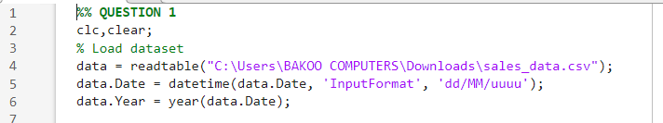

**Step 2: writing codes in MATLAB**

From the knowledge of plotting we acquired from module 4, using functions such as “bar”, “groupsummary”,” categorical”, “pie”, ”grid on”,”bar3”, ”scatter”, ”saveas”, etc, we managed to write codes that plot pie charts, bar graphs, histograms in both 3D and 2D and saved them as images.

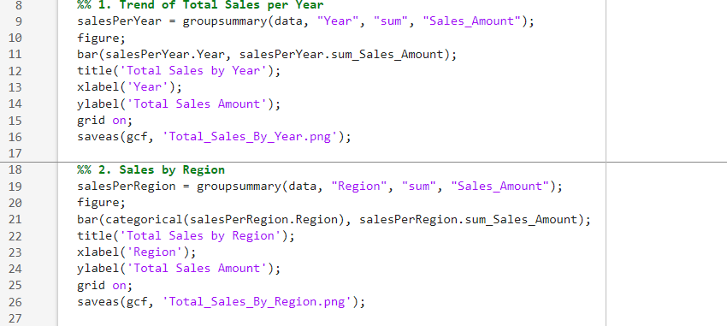

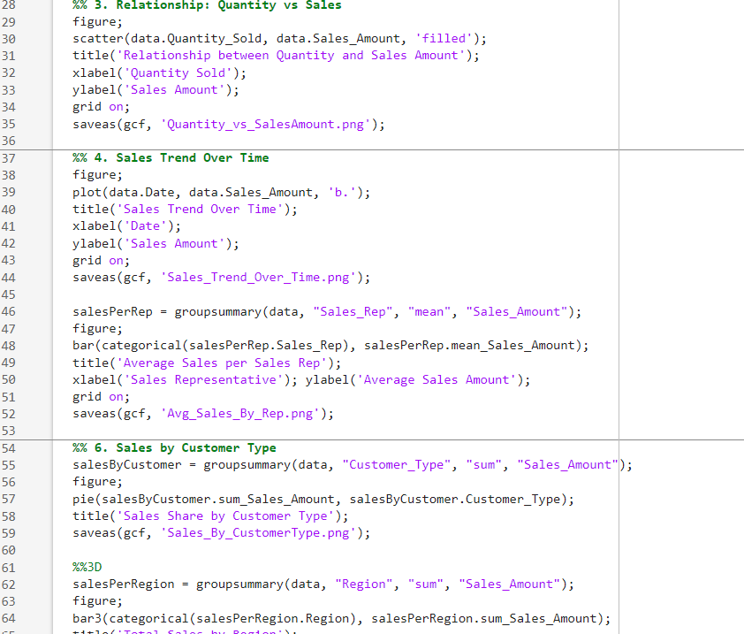

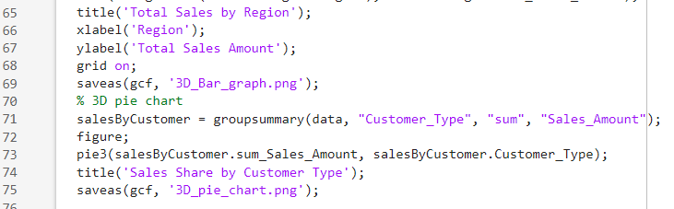

**3.3 Results**

After running the coded, it produced the following outputs

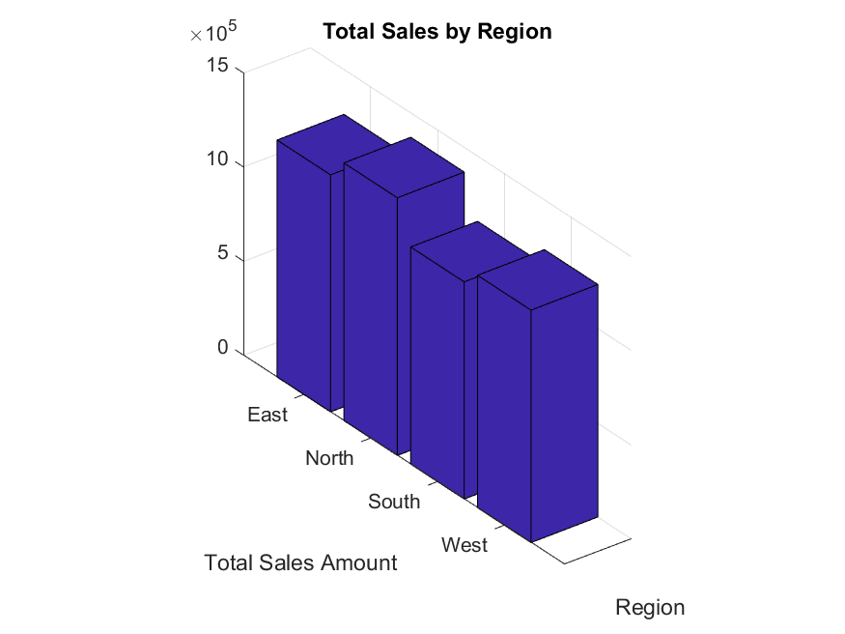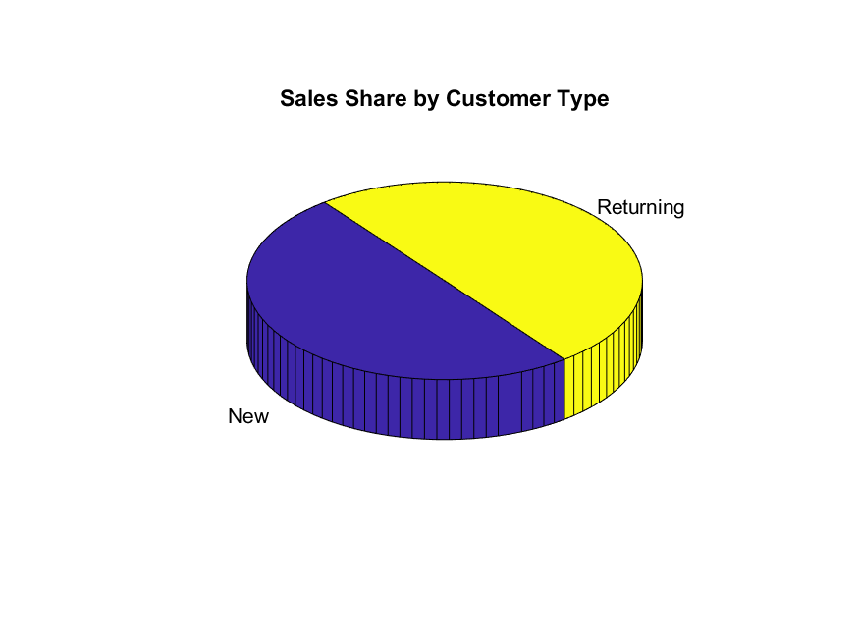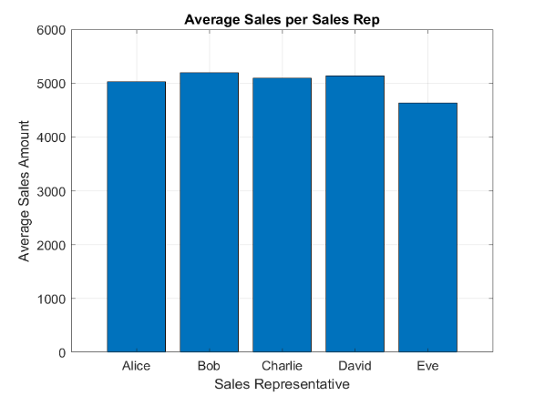

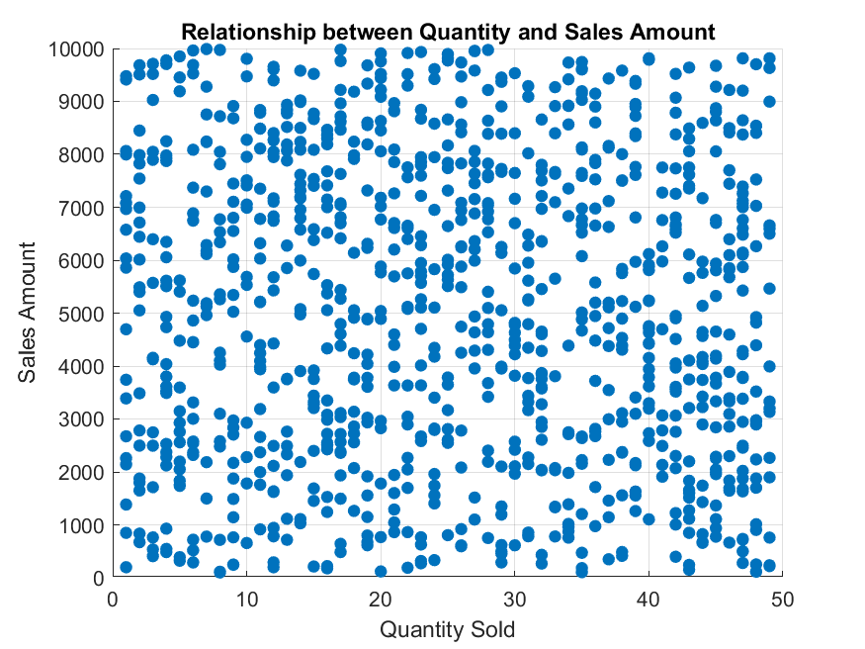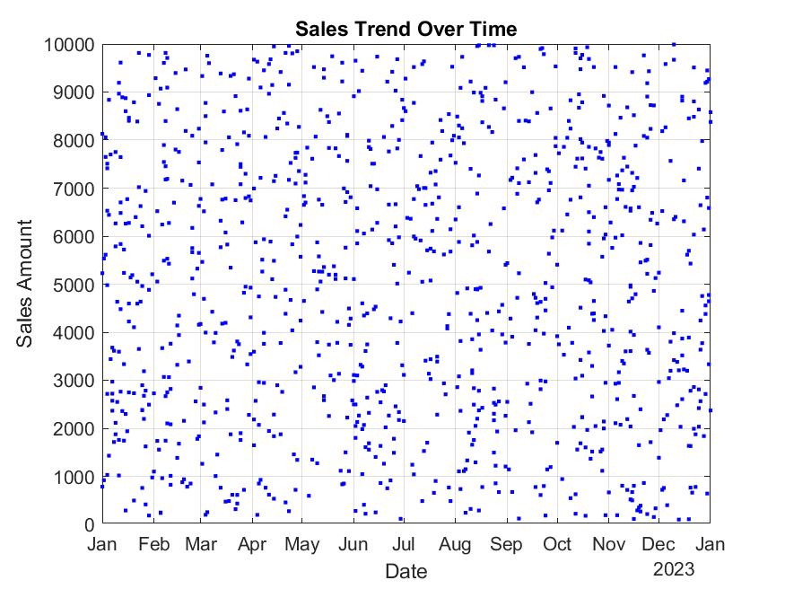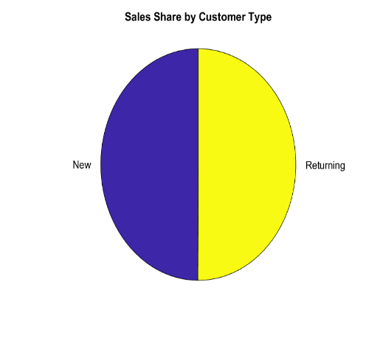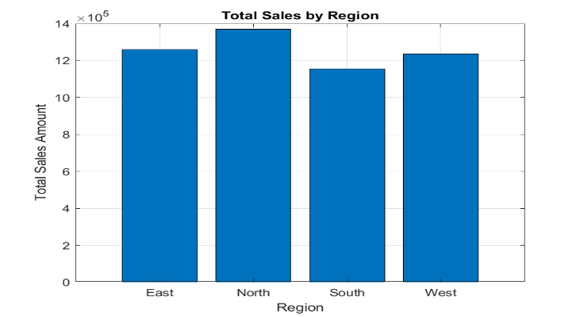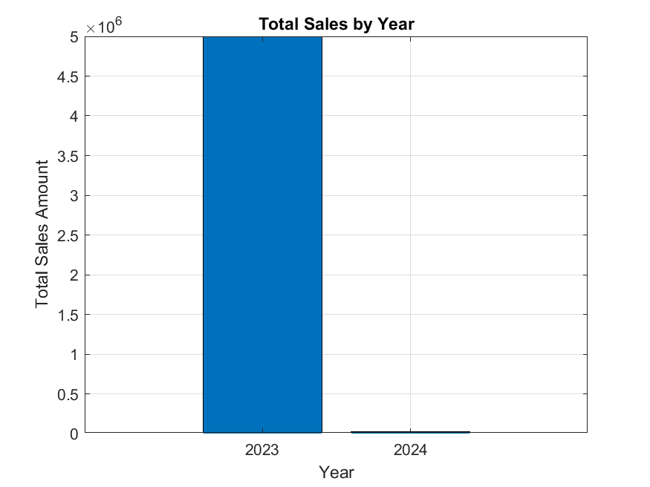

# CHAPTER FOUR: QUESTION 2

## 4.1 Introduction

Here we were required to describe the different statistical characteristics in our data and visualise them while ensuring that the different attributes collected per individual are detailed enough to describe them

## 4.2 steps

**Step1: loading MATLAB file and changing struct2table into table**

We used the “load” function to load the matlab file “Student.mat” into Matlab, we also used “struct2table” functions to change structure to table.

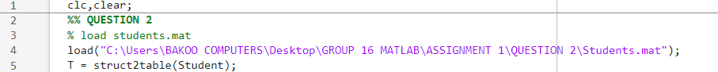

**Step 2: writing codes**

From the knowledge of plotting we acquired from module 4, using functions such as “bar”, “groupsummary”, “categorical”, ”pie”, ”grid on”,”bar3”, ”scatter”, ”saveas”, etc, we managed to write codes that plot pie charts, bar graphs, histograms in both 3D and 2D and saved them as images.

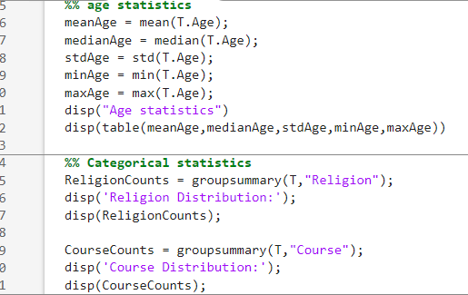

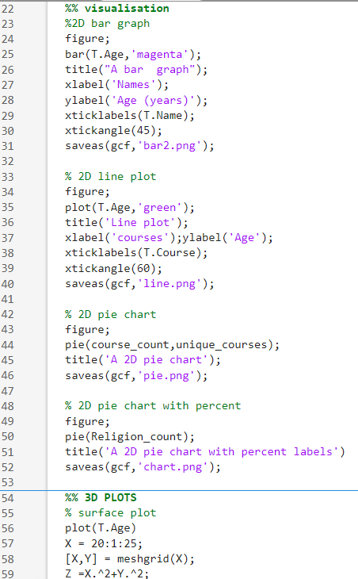

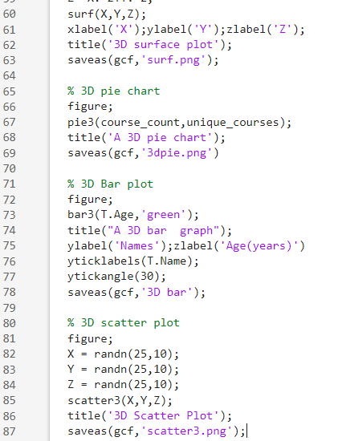

**4.3 Results**

After running the code, it produced the following outputs

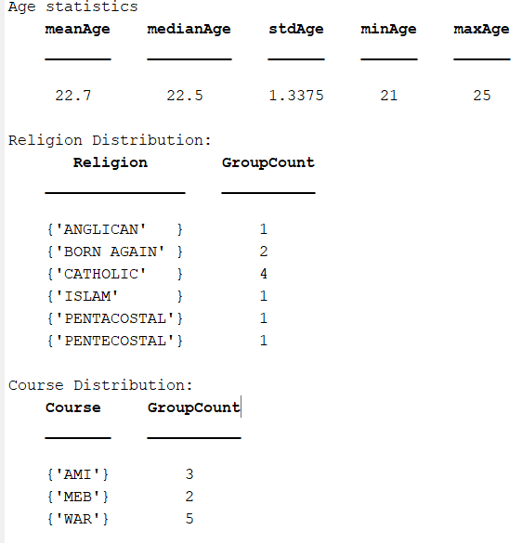

**Visual statistics**

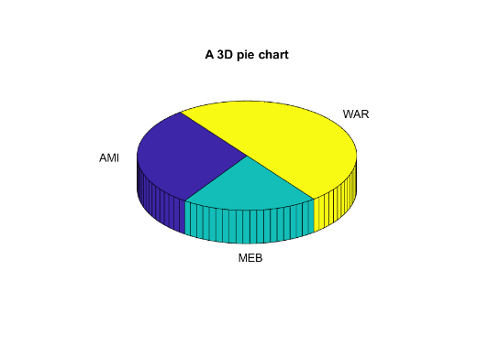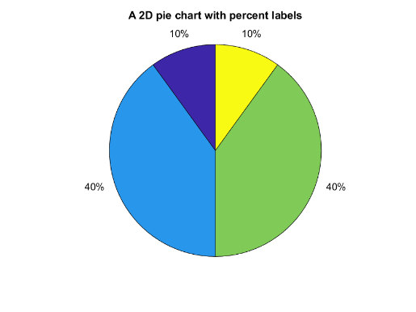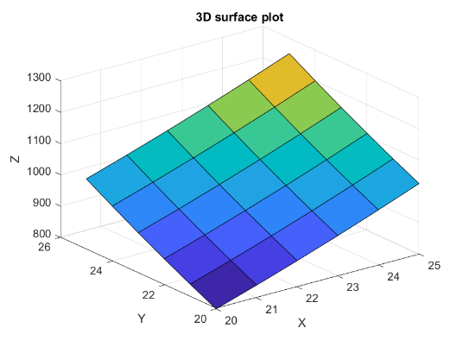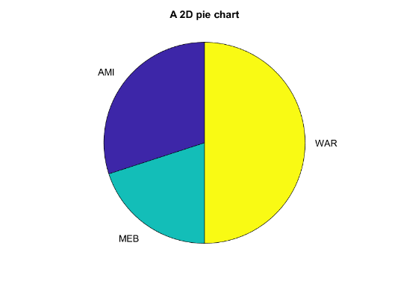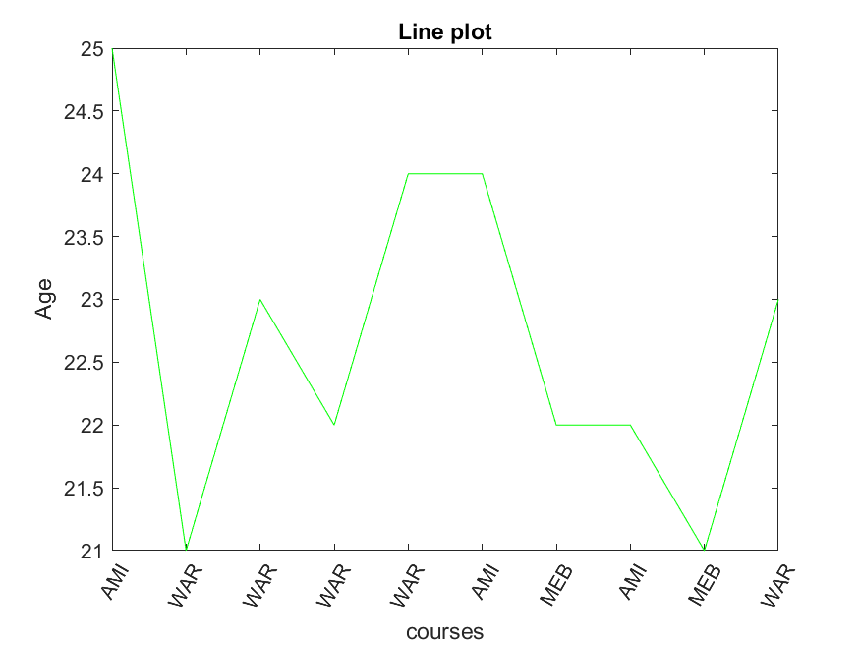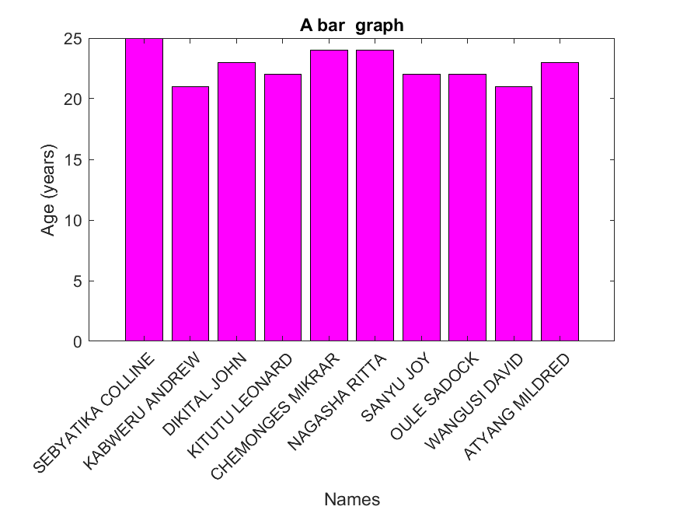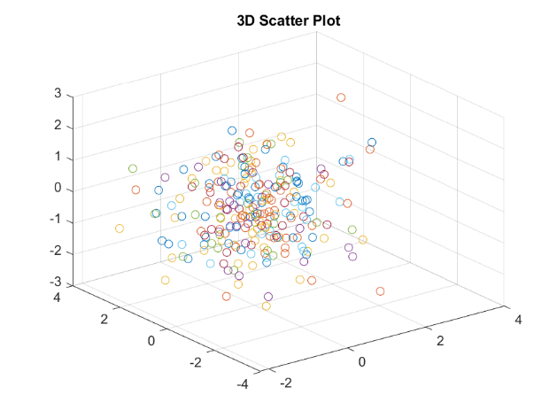

# CHAPTER FIVE: RECOMMENDATIONS AND CONCLUSION

## 5.1 Conclusion:

The study achieved its objectives by analysing the data and presenting meaningful results. The findings highlighted key patterns and demonstrated the importance of teamwork and systematic approaches in producing reliable outcomes.

## 5.2 Recommendations:

* Furtherattention should be given to improve data collection and analysis methods in order to ensure more accurate results.
* Group members should continue collaborating closely, as team work played a key role in the success of this assignment
* Clear documentation and systematic reporting should always be maintained to enhance understand, reproducibility, and practical application of the results.

# CHAPTER SIX: REFERENCES

* MATLAB Documentation: <https://www.mathworks.com/help/matlab>
* course Lecture notes (module 1 – 4)

# APPENDICES

